Advanced Engineering Mathematics, by Erwin Kreyszig 10th. Ed.

**Problem Set 7.4**

No. 1

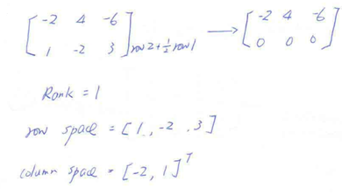

No. 2



No. 3

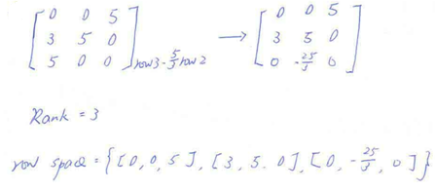

No. 4



No. 5

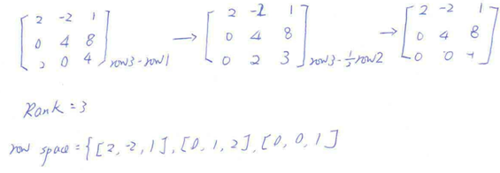

No. 6



No. 7

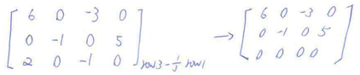

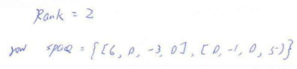

No. 8



No. 9

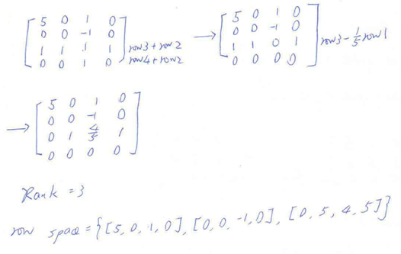

No. 10



No. 11

問答或證明題，不解

No. 12

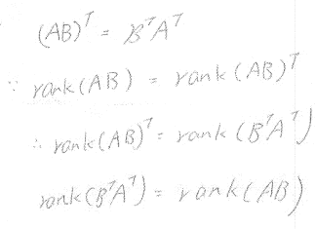

No. 13

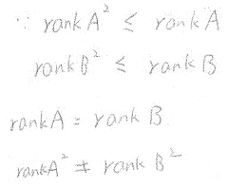

No. 14

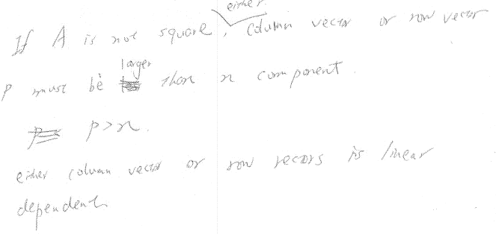

No. 15

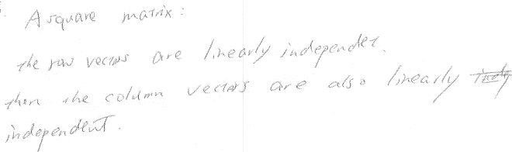

No. 16

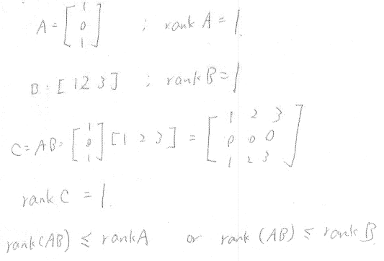

No. 17

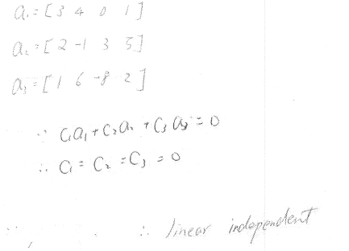

No. 18



No. 19

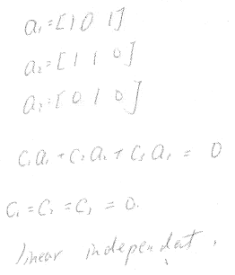

No. 20



No. 21

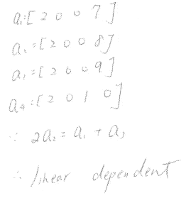

No. 22



No. 23

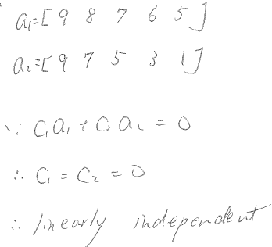

No. 24



No. 25

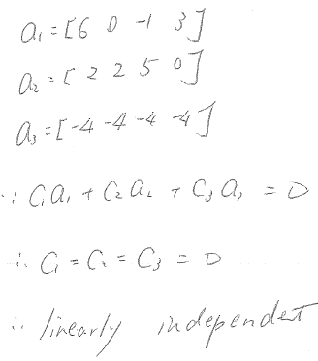

No. 26



No. 27



No. 28



No. 29



No. 30



No. 31



No. 32



No. 33

問答或證明題，不解

No. 34



No. 35

問答或證明題，不解